

DVTK Design Specification
Emulator, Media and Scripting Libraries

1.0
2005-06-29

Table of Contents
1 Introduction 6
1.1 Purpose 6
1.2 Scope 6
1.3 Audience 6
1.4 Abbreviations and acronyms 6
1.5 References 6
1.6 History 6
2 Emulator Concepts 7
2.1 Storage SCP Emulator 7
2.1.1 General Storage 7
2.1.2 Storage Commitment Support 7
2.2 Storage SCU Emulator 7
2.3 Print SCP Emulator 8
2.4 Emulator Transfer Syntaxes 8
2.5 Global design of Emulator component 8
3 Detail Design of Emulator Classes 10
3.1 Base SCP Emulator Class 10
3.1.1 Virtual methods 10
3.1.2 Send a DIMSE response over the current association 11
3.1.3 Emulating as SCP 11
3.1.4 Getting the emulator session 11
3.1.5 Setting the logger & serializer for logging activities 11
3.1.6 Set the owner thread ID for the association's socket 11
3.2 Detail Design of Storage SCP Emulator Class 11
3.2.1 Processing the C-STORE-RQ with dataset 11
3.2.2 Processing the N-ACTION-RQ with dataset 11
3.2.3 Adding the supported Storage presentation contexts 12
3.2.4 Processing the Storage commands and dataset 12
3.2.5 Processing the command responses 12
3.2.6 Logging 12
3.3 Image Display File Class 12
3.3.1 Executing the image display formats 12
3.4 Storage Commitment Class 13
3.5 Setting/Getting the transaction UID 14
3.6 Managing the SOP instances 14
3.7 Getting the Stored/Failed SOP instances 14
3.8 Setting/Getting the SOP Class & SOP instance UID 14
3.9 Setting the flag for send event 14
3.10 Building the storage commitment from the given dataset 14
3.11 Building an N-EVENT-REPORT-RSP dataset 14
3.12 Checking the flag for send event 14
4 Detail Design of Storage SCU Emulator Class 15
4.1 Sending the data on multiple associations 16
4.2 Sending the data on single association 16
4.3 Importing & validating the media file 16
4.4 Starting the Storage SCU emulation 16
4.5 Performing a verification SOP Class association/send/release 16
4.6 Reporting the storage commitment event 16
4.7 Adding/Removing the data file 17
4.8 Managing the User options for Storage SCU 17
4.8.1 Setting the number of repetitions for sending data 17
4.8.2 Setting the logger & serializer for logging activities 17
5 Detail Design of Printer SCP Classes 18
5.1 Print SCP Emulator Class 18
5.1.1 Processing the N-ACTION Print command 18
5.1.2 Processing the N-CREATE Print dataset 19
5.1.3 Processing the N-DELETE Print command 19
5.1.4 Processing the N-GET Print command 19
5.1.5 Processing the N-SET Print command 19
5.1.6 Adding the supported Print presentation contexts 19
5.1.7 Processing the Print commands 19
5.1.8 Sending Printer Status Event over association 20
5.1.9 Generating a SOP instance UID 20
5.2 Relationship between Printer Classes 20
5.3 Base SOP Class 20
5.3.1 Getting SOP class & SOP instance UID 21
5.3.2 Setting/Getting the dataset 21
5.3.3 Setting/Getting the logger 21
5.4 Basic Film Session Class 21
5.4.1 Adding/Removing the film boxes 22
5.4.2 Adding/Removing the image overlay 22
5.4.3 Adding/Removing the VOI LUT boxes 22
5.4.4 Getting the number of film boxes 23
5.4.5 Getting the number of image overlay 23
5.4.6 Getting the number of VOI LUT boxes 23
5.4.7 Checking for the film boxes 23
5.4.8 Checking for the image overlay 23
5.4.9 Checking for the VOI LUT boxes 23
5.4.10 Getting the film box 23
5.4.11 Getting the image overlay 23
5.4.12 Getting the VOI LUT box 23
5.4.13 Printing the film 23
5.5 Basic Film Box Class 24
5.5.1 Adding/Removing the image boxes 24
5.5.2 Adding/Removing the annotation boxes 25
5.5.3 Getting the number of image boxes 25
5.5.4 Getting the number of annotation boxes 25
5.5.5 Checking for the image boxes 25
5.5.6 Checking for the annotation boxes 25
5.5.7 Getting the image box 25
5.5.8 Getting the annotation box 25
5.5.9 Creating the film box 25
5.5.10 Printing the film box 25
5.6 Print Queue Class 25
5.6.1 Getting the single instance of Print queue class 26
5.6.2 Adding/Removing the printer jobs 26
5.6.3 Getting the number of printer jobs 26
5.6.4 Getting the printer job 26
5.6.5 Checking for the printer job 26
5.6.6 Getting the next printer job 26
5.6.7 Getting the print queue 26
5.7 Printer Class 27
5.7.1 Getting the single instance of Printer class 28
5.7.2 Adding/Removing the printer jobs 28
5.7.3 Getting the number of printer jobs 28
5.7.4 Getting the printer ststus info defined term from definition file 28
5.7.5 Getting the printer information 28
5.7.6 Managing the image display & annotation formats 28
5.7.7 Managing the presentation LUTs 28
5.7.8 Managing the image boxes 28
5.8 Image Box Class 29
5.8.1 Setting the dataset 29
5.9 Annotation box class 29
5.10 Presentation LUT class 29
5.11 Format Description Class 29
5.11.1 Getting the number of image boxes 29
5.11.2 Getting the image display format 30
6 Media Concepts 31
7 Detail Design of Media Classes 32
7.1 Media File Header Class 32
7.1.1 Setting/Getting the media filename 33
7.1.2 Setting the file handle 33
7.1.3 Setting/Getting the FMI Preamble 33
7.1.4 Setting/Getting the FMI Dicom prefix 33
7.1.5 Setting/Getting the FMI transfer syntax 33
7.1.6 Streaming the media file header and dataset from the media file 33
7.1.7 Streaming the media file preamble, DICOM prefix and file Meta information into the media file 33
7.1.8 Encoding media header to data transfer stream 34
7.1.9 Decoding media header from data transfer stream 34
7.1.10 Updating the warehouse with media header object 34
7.2 Media File Dataset Class 35
7.2.1 Setting/Getting the filename 35
7.2.2 Setting/Getting the FMI Transfer Syntax 35
7.2.3 Setting/Getting the FMI 36
7.2.4 Setting/Getting the Dataset 36
7.2.5 Getting the DICOMDIR dataset 36
7.2.6 Get the next DICOMDIR Record 36
7.2.7 Streaming the DICOM objects from the media file 36
7.2.8 Streaming the DICOM object to file 36
7.2.9 Clearing the File Meta Information 36
7.2.10 Clearing the Dataset 37
7.2.11 Setting the Storage Mode 37
7.2.12 Setting the Logger 37
7.3 Media File Tail Class 37
7.3.1 Setting/Getting the filename 38
7.3.2 Setting/Getting the Trailing Padding value 38
7.3.3 Setting/Getting the Sector Size 38
7.3.4 Setting/Getting the Padding Value 38
7.3.5 Updating the file tail object in warehouse 38
7.3.6 Streaming the dataset trailing padding into the media file 38
8 Scripting Concept 39
8.1 Script Language 39
8.1.1 DICOMScript 39
8.1.2 DICOMSuperScript 40
8.1.3 VBScript 40
9 Detail Design of Script classes 41
9.1 Parser Instance Class 41
9.1.1 Cleaning up instance 41
9.1.2 Allocating the first free parser 41
9.1.3 Freeing up the indexed parser 41
9.1.4 Checking if a parser is available 41
9.1.5 Initializing the parser instances 41
9.2 DICOM Script Class 42
9.2.1 Parsing the script file 42
9.2.2 Executing the script file 42
9.2.3 Setting the SuperScript file 42
9.3 DICOM Super Script Class 43
9.3.1 Executing super script file 43
9.3.2 Parsing the super script file 43
9.3.3 Removing unwanted characters from super script file 43

Introduction

Purpose
This document describes the global and detail design of the Emulators, Media and scripting components. This is a living document and changes in the design should be laid down in this document. Especially the sections on detailed design of Emulators, Media and scripting classes may change during the project.

Scope
This document defines all the classes used to describe the different types of sessions used by the DICOM Validation Tool.

Audience
This document is intended for all the implementers in the DVT project. The reader is assumed to have basic DICOM knowledge.

Abbreviations and acronyms
Abbreviation / acronym | Description
AE | Application Entity
Definition File | File containing the DICOM SOP Class description(s).
DVT | DICOM Validation Tool.
Session File | File containing the test session parameters.
User | Person who is implementing the Definition library.
SUT | System Under Test - Product being tested by DVT for conformance to DICOM.
SCP | Service Class Provider
SCU | Service Class User
VR | Value Representation

References
Reference | Title | Author/Publisher | Document number
SESSION | Test Session File Specification | R. Busbridge | XZS 980-000119.00
SCRIPT | DICOMScript Language Specification | R. Busbridge | XZS 980-000118.00
DESIGNSPEC |  | R. Busbridge  M. van Minderhout | XZS 980-000183.01
PATTERNS | Design Patterns | E. Gamma et al. | ISBN 0201633612
DCM | DICOM standard 2004 | NEMA | PS 3.0-2004

History
Version | Date | Author | Description
0.1 | 01 June 2005 | Piyush Bhageriya  Manisha Singla | Initial version
1.0 | 29 June 2005 | Piyush Bhageriya  Manisha Singla | Update for OpenSource release

Emulator Concepts
An emulator is accessed through an Emulator Session. An emulator session is used when DVT acts as an SCU or SCP emulator.
The main purpose of emulators is as follows:
- It can be used as DICOM ‘dump’ node when it works as storage SCP.
- It can be used to send DICOM files to a remote system when it works as storage SCU.
- It can be used to validate incoming objects for all the supported SOP classes.

Storage SCP Emulator

General Storage
DVT will act as an SCP for the Storage SOP Classes. This emulator also performs the image (Object) relationship analysis. The Emulator automatically supports the Verification SOP Class.

Storage Commitment Support
DVT will act as a Storage Commitment SCP emulator if the Storage Commitment PUSH Definition File is loaded into a Storage SCP Emulator session.
A Storage SCP Emulator Session supporting only Storage Commitment PUSH can be started on a separate TCP/IP port number if necessary.
DVT will maintain a list of the SOP Class UID/SOP Instance UID pairs for each storage instance received since the Storage SCP Emulator was started. When the SUT (acting as SCU) issues the N-ACTION-RQ Storage Commitment DVT will check the list of stored instances and flag any being committed for storage. DVT will then respond with a successful N-ACTION-RSP.
DVT will then wait for a fixed delay (currently 5 seconds) before making an association with the SUT in order to send the N-EVENT-REPORT-RQ Storage Commitment. DVT will use the SCP/SCU Role Selection when requesting the association and check that the same is returned by the SUT in the acceptance. DVT will send successful storage commitment for all requested storage instances that are found in the list and failed storage commitment for any request but not found.
NOTE: In order to allow DVT to make the association define the SUT IP address and port number using the SUT ACSE Properties Remote Host Name and Remote Connect Port.

Storage SCU Emulator
DVT will act as a Storage SCU for the Media files selected. The required Storage SOP Classes, for the selected Media files, can be specified in the DVT. The user may request a Verification Association and issue a C-ECHO-RQ to the SCP and send the selected. The way in which the selected Media files are handled can be controlled by the following parameters.
- Single/Multiple Association – Define how the Association will be handled when more than one Media file is selected or the Repeat count is greater than one. DVT will either send all selected Media files during a single Association or request a new Association for each Media file selected.
- Validate on import – Validate the Media file against the appropriate Definition File during import (before sending the Media file to SCP).
- Repeat x 1 – Indicate the number of times that the selected Media files should be sent to the SCP. This is useful when running a duration test on the SCP.

Print SCP Emulator
DVT will act as an SCP for a Print SOP class. It is recommended to work with one Print Meta SOP Class at a time. If the Print Job SOP Class Definition File is loaded, DVT will support the Print Job Service Class.
If “SLIDE”, “SUPERSLIDE” or “CUSTOM” Image Display Formats [DICOM tag (2010,0010)] are to be sent, the number of images for each format must be defined in the “ImageDisplayFormat.dat” data. This file must also be modified to indicate the number of annotation boxes defined if the Annotation Display Format ID [DICOM tag (2010,0030)] is to be used.

Emulator Transfer Syntaxes
The User should select the Transfer Syntaxes that are to be supported by the emulator.
The user can specify a Transfer Syntax that DVT will accept when working in emulation mode. This parameter is repeated for each Transfer Syntax supported by DVT.
When an SCU emulator is being used, DVT will propose all the chosen Transfer Syntaxes once per SOP Class being used – i.e., If Implicit VR Little Endian and Explicit VR Big Endian are chosen, then DVT will propose two Presentation Contexts for each SOP Class being used. DVT does not combine the Transfer Syntaxes into a single Presentation Context, but allows the SCP to decide which will be supported during the Association.
When an SCP emulator is being used, DVT will accept Presentation Contexts from the SCU where the proposed SOP Class/Transfer Syntax matches the Transfer Syntaxes chosen for the SOP Classes being used.
When the User starts a New Emulator Session, the Implicit VR Little Endian Transfer Syntax is selected as the default value.

Global design of Emulator component
DVT supports different emulator types as given:
- Verification SCU emulator
- Verification SCP emulator
- Storage SCU emulator
- Storage SCP emulator
- Storage Commitment SCP emulator
- Print SCP emulator

The different emulators provided in DVT GUI emulate Storage and Printing SOP classes. The DVT can be used as both SCU and SCP for Storage SOP classes and SCP for Printer SOP class. The Emulators automatically support the Verification SOP Class.

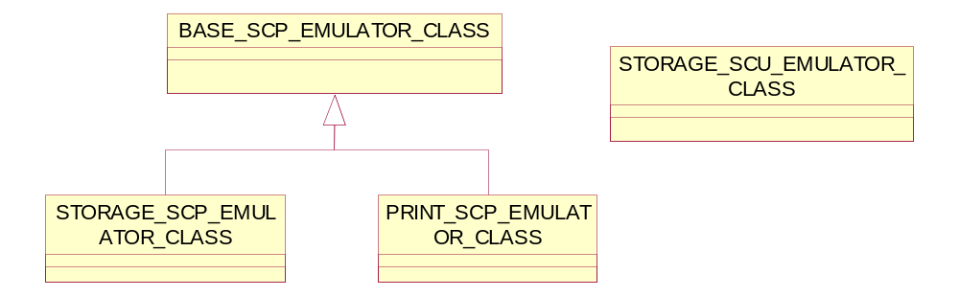
Figure 1 Relationship diagram for Emulator classes

The BASE_SCP_EMULATOR_CLASS is an abstract class and modeled to have SCP functionality for storage and printer SOP classes. The STORAGE_SCP_EMULATOR_CLASS and PRINTER_SCP_EMULATOR_CLASS derived from base SCP class and implements functionality specific to SOP classes.
The STORAGE_SCU_EMULATOR_CLASS contains all SCU functionality for storage SOP classes.

Detail Design of Emulator Classes

Base SCP Emulator Class
The Base SCP Emulator class is an abstract class and manages all SCP functionalities for Storage and Printer SOP classes.

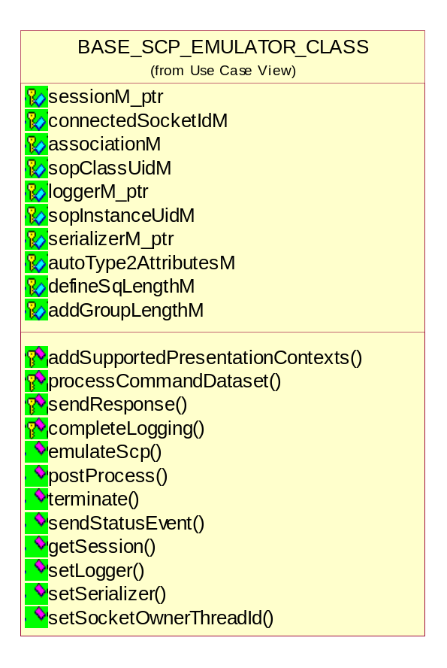
Figure 2 Class diagram of Base SCP Emulator

Virtual methods
The following methods are pure virtual and implemented by the derived classes.

virtual bool postProcess();
virtual bool terminate();
virtual bool sendStatusEvent();
virtual bool addSupportedPresentationContexts();
virtual bool processCommandDataset(DCM_COMMAND_CLASS*, DCM_DATASET_CLASS*);
virtual void completeLogging();

Send a DIMSE response over the current association
bool sendResponse(DIMSE_CMD_ENUM, UINT16 status = DCM_STATUS_SUCCESS, DCM_DATASET_CLASS *dataset_ptr = NULL);

Emulating as SCP
bool emulateScp();
This method provides SCP emulation for a single association.

Getting the emulator session
EMULATOR_SESSION_CLASS *getSession();

Setting the logger & serializer for logging activities
void setLogger();
void setSerializer(BASE_SERIALIZER*);

Set the owner thread ID for the association's socket
bool setSocketOwnerThreadId(THREAD_TYPE tid);

Detail Design of Storage SCP Emulator Class
The Storage SCP Emulator class used for SOP class UID name mapping.

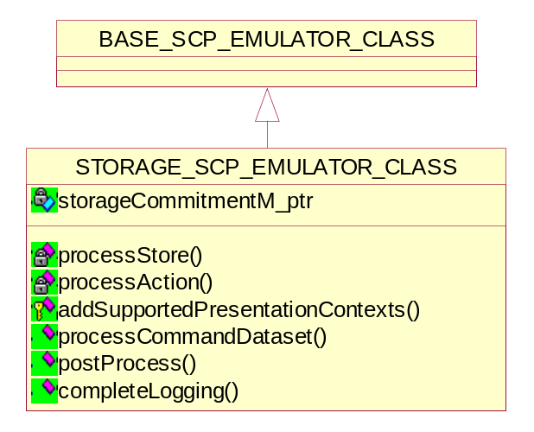
Figure 3 Class diagram of Storage SCP Emulator

Processing the C-STORE-RQ with dataset
bool processStore(DCM_DATASET_CLASS*);

Processing the N-ACTION-RQ with dataset
bool processAction(DCM_DATASET_CLASS*);

Adding the supported Storage presentation contexts
bool addSupportedPresentationContexts();

Processing the Storage commands and dataset
bool processCommandDataset(DCM_COMMAND_CLASS*, DCM_DATASET_CLASS*);

Processing the command responses
bool postProcess();
This method performs any association release post processing and sends an event report for storage commitment.

Logging
void completeLogging();
This method completes the emulation logging by displaying any relationships.

Image Display File Class
The different Image Display Formats [DICOM tag (2010,0010)] and Annotations are defined in [DCM] part-3 used during printing operation.
The image display file (“ImageDisplayFormat.dat”) is ASCII text file and can be edited by user. The image display file format can formally be described in Backus-Naur Form (BNF) and defines Image Display Formats [DICOM tag (2010,0010)], the number of images. This file must also indicate the number of annotation boxes if the Annotation Display Format ID [DICOM tag (2010,0030)] is to be used. The Lex/yacc parser should be written for parsing the image display file.
This class represents the image display file. It derived from BASE_FILE_CLASS and implements the image display formats used during printing operation.

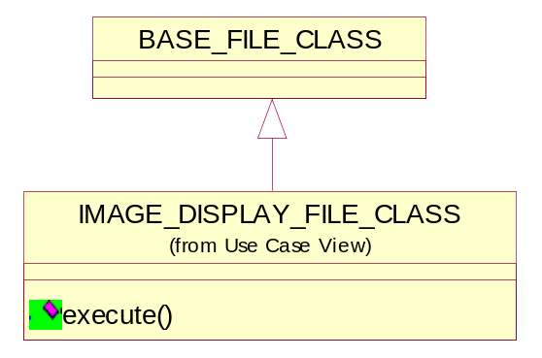
Figure 4 Class diagram of Image Display File

Executing the image display formats
bool execute();
This method is used to instantiate the execution of a session.

Storage Commitment Class
The Storage Commitment mechanism currently defined in DICOM for network based storage of SOP Instances. The Storage Service Class allows a SCU to transmit images and other information (such as overlays and curves) to a SCP but it does not specify that the SCP explicitly take responsibility for the safekeeping of data into account. That is, there is no commitment that the SCP will do more than accept the transmitted SOP Instances. In order to have medical image management in addition to medical image communication, there is a need for a Service Class within DICOM that ensures that there is an explicitly defined commitment to store the SOP Instances.
The Storage Commitment Service Class defines an application-level class-of-service, which facilitates this commitment to storage. The Storage Commitment Service Class enables an AE acting as an SCU to request another AE acting as an SCP to make the commitment for the safekeeping of the SOP Instances (i.e. that the SOP Instances will be kept for an implementation specific period of time and can be retrieved). The AE where such SOP Instances can later be retrieved may be the SCP where storage commitment was accepted or it may be distinct from that SCP. The SCP implementation defines how it provides its commitment to storage. Certain SCPs may commit to permanently store the SOP Instances (e.g. an archive system) while other SCPs may commit to provide storage of the SOP Instances for a limited amount of time. The SCP is required to document in its Conformance Statement the nature of its commitment to storage (e.g. duration of storage, retrieve capabilities and latency, capacity).
Once the SCP has accepted the commitment to store the SOP Instances, the SCU may decide that it is appropriate to delete its copies of the SOP Instances.

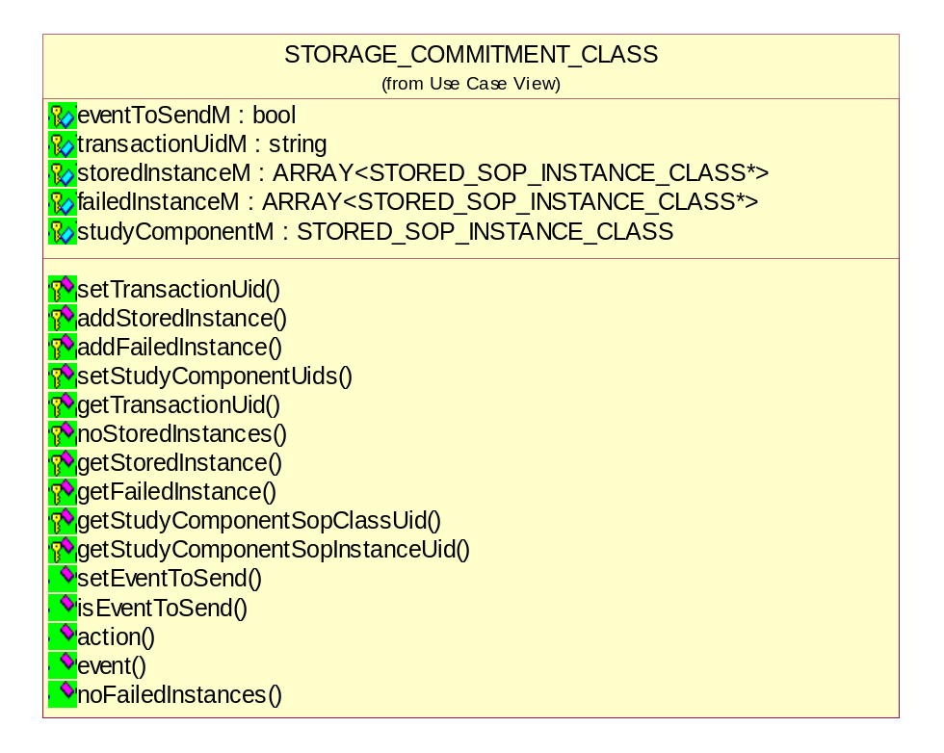
Figure 5 Class diagram of Storage Commitment
This class implements the storage commitment using the Push Model. The Push model expects an SCU to transmit SOP Instances to an SCP using an appropriate mechanism outside the scope of this Service Class. Storage commitment is then initiated by transmitting a Storage Commitment Request containing references to a set of one or more SOP Instances. Success or failure of storage commitment is subsequently indicated via a notification from the SCP to the SCU.

Setting/Getting the transaction UID
void setTransactionUid(string transactionUid);
string getTransactionUid();

Managing the SOP instances
void addStoredInstance(string, string);
void addFailedInstance(string, string);
STORED_SOP_INSTANCE_CLASS *getStoredInstance(UINT);
STORED_SOP_INSTANCE_CLASS *getFailedInstance(UINT);

Getting the Stored/Failed SOP instances
UINT noStoredInstances();
UINT noFailedInstances();

Setting/Getting the SOP Class & SOP instance UID
void setStudyComponentUids(string sopClassUid, string sopInstanceUid);
string getStudyComponentSopClassUid();
string getStudyComponentSopInstanceUid();

Setting the flag for send event
void setEventToSend(bool eventToSend);

Building the storage commitment from the given dataset
UINT16 action(DCM_DATASET_CLASS*, LOG_CLASS*);

Building an N-EVENT-REPORT-RSP dataset
UINT16 event(DCM_DATASET_CLASS**, LOG_CLASS*);

Checking the flag for send event
bool isEventToSend();

Detail Design of Storage SCU Emulator Class
This class provides the functionality to DVT to send data on the network to SCP. The DVT emulates as storage SOP class SCU. The user can send data from the file through DVT GUI. The user has various options for emulating as storage SCU:
- User can use Single/Multiple associations for sending data over the network.
- User can ask DVT to validate data after importing.
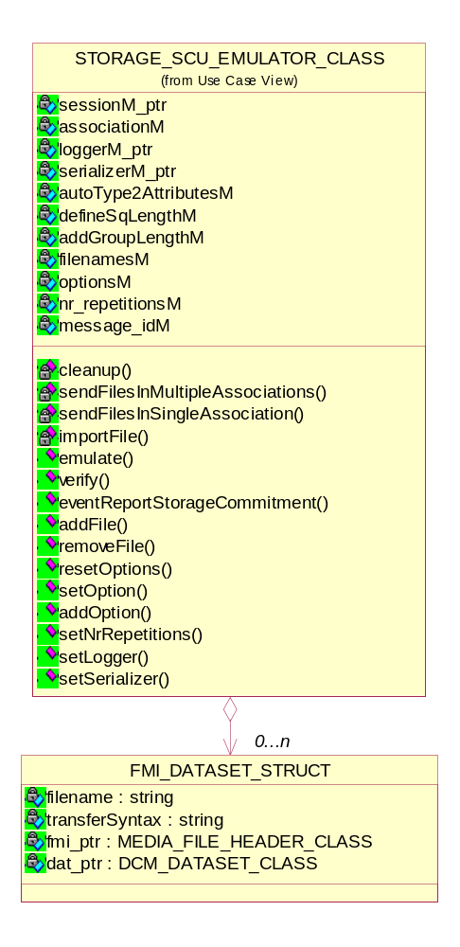
Figure 6 Class diagram of Storage SCU Emulator

Sending the data on multiple associations
bool sendFilesInMultipleAssociations();

Return value | Explanation
true | The operation is successful.
false | The operation is failed.

Sending the data on single association
bool sendFilesInSingleAssociation();

Return value | Explanation
true | The operation is successful.
false | The operation is failed.

Importing & validating the media file
bool importFile(string filename);

Return value | Explanation
true | The operation is successful.
false | The operation is failed.

Starting the Storage SCU emulation
bool emulate();

Return value | Explanation
true | The operation is successful.
false | The operation is failed.

Performing a verification SOP Class association/send/release
bool verify();

Return value | Explanation
true | The operation is successful.
false | The operation is failed.

Reporting the storage commitment event
bool eventReportStorageCommitment(UINT16, DCM_DATASET_CLASS*);

Return value | Explanation
true | The operation is successful i.e if the N_EVENT_REPORT request command is successful.
false | The operation is failed.

Adding/Removing the data file
void addFile(string filename);
void removeFile(string filename);

Managing the User options for Storage SCU
UINT resetOptions();
UINT setOption(UINT option);
UINT addOption(UINT option);
The options provided to the user are:
User can use Single/Multiple associations for sending data over the network.
User can ask DVT to validate data after importing.

Setting the number of repetitions for sending data
void setNrRepetitions(UINT nr);

Setting the logger & serializer for logging activities
void setLogger();
void setSerializer(BASE_SERIALIZER*);

Detail Design of Printer SCP Classes

Print SCP Emulator Class
The Print SCP System acquires the images with the demographics and presentation information from the connected Print SCU. The images are then processed and formatted and finally queued as a print job on the Printer queue. If the Printer is operating normally, then the film sheets described in the print-job will be printed. Changes in the Printer operation status will be detected (e.g. film Magazine empty) and reported back to the Print SCU. If the Printer is not operating normally, then the print-job will be set to an error state and can be restarted by the user via the job control interface.
The Print SCP performs following activities:
- DICOM Association and Negotiation
- Image Buffering
- Image Formatting (Film sheet format)
- Printing
- Print Job Status Tracking
- Print Status Tracking

The Printer Status can be requested at any time by the Print SCU, while the Print Server will update the Print SCU asynchronously whenever the Printer status get changed. Furthermore, the Print Server provides in addition a Service operation of checking the networking connectivity to it’s Print SCU using the Verification SOP Class.

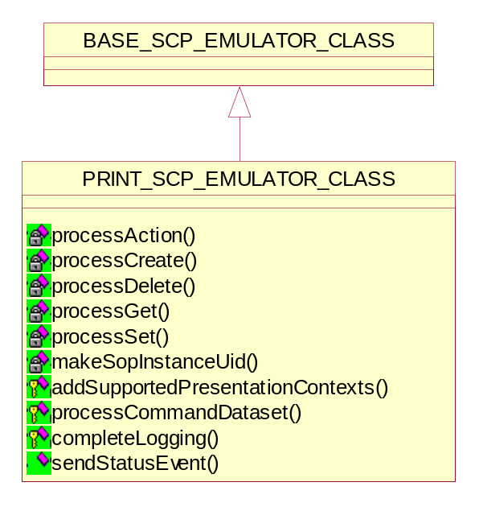
Figure 7 Class diagram of Print SCP Emulator

Processing the N-ACTION Print command
bool processAction();

Return value | Explanation
true | The operation is successful.
false | The operation is failed.

Processing the N-CREATE Print dataset
bool processCreate(DCM_DATASET_CLASS*);

Return value | Explanation
true | The operation is successful.
false | The operation is failed.

Processing the N-DELETE Print command
bool processDelete();

Return value | Explanation
true | The operation is successful.
false | The operation is failed.

Processing the N-GET Print command
bool processGet(DCM_COMMAND_CLASS*);

Return value | Explanation
true | The operation is successful.
false | The operation is failed.

Processing the N-SET Print command
bool processSet(DCM_DATASET_CLASS*);

Return value | Explanation
true | The operation is successful.
false | The operation is failed.

Adding the supported Print presentation contexts
bool addSupportedPresentationContexts();

Return value | Explanation
true | The operation is successful.
false | The operation is failed.

Processing the Print commands
bool processCommandDataset(DCM_COMMAND_CLASS*, DCM_DATASET_CLASS*);

Sending Printer Status Event over association
bool sendStatusEvent();

Generating a SOP instance UID
void makeSopInstanceUid();

Relationship between Printer Classes
The Print Management Service Class defines an application-level class-of-service which facilitates the printing of images and image related data on a hard copy medium. All the printer classes and their relationship are shown in the following diagram.

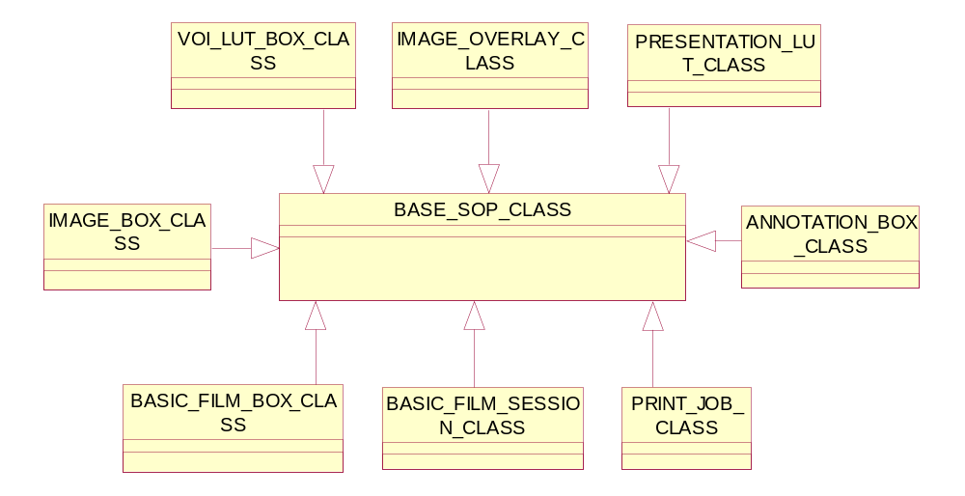
Figure 8 Relationship diagram of Printer classes

Base SOP Class

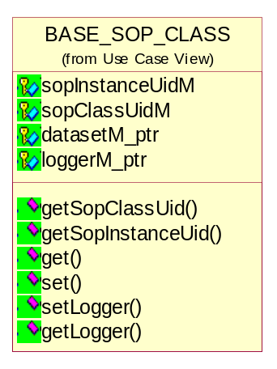
Figure 9 Class diagram of Base SOP

Getting SOP class & SOP instance UID
string getSopClassUid();
string getSopInstanceUid();

Setting/Getting the dataset
DCM_DATASET_CLASS *get();
virtual UINT16 set(DCM_DATASET_CLASS*);

Setting/Getting the logger
void setLogger(LOG_CLASS *logger_ptr);
LOG_CLASS *getLogger();

Basic Film Session Class
The Film Session class is responsible for acquiring all the information, which is
required to print the film session. The film session contains one or more films related in a user-defined way (e.g., belonging to the same exam, patient) that are originated from one host (e.g., workstation, diagnostic modality) and that are printed on one hard copy printer.
Each film consists of one or more images and zero or more film related annotations. An
annotation consists of one or more lines of text.
Each image consists of pixel data and zero or more overlay planes. The user controls the look of the film by assigning values to print parameters.
Print parameters are defined at film session, film, image and annotation levels. The parameter level determines the scope of operation of the print parameters (e.g., print parameters of the image level are valid for the corresponding image).
The inputs to the Film Session are:
- Set of images and image related data
- Presentation data that describes the visual look of the films
The output of the Film Session is the Print Job, which contains all the information to print the film session.
The Basic Film Session class describes the presentation parameters, which are common for all the films of a film session (e.g. number of films, film destination)

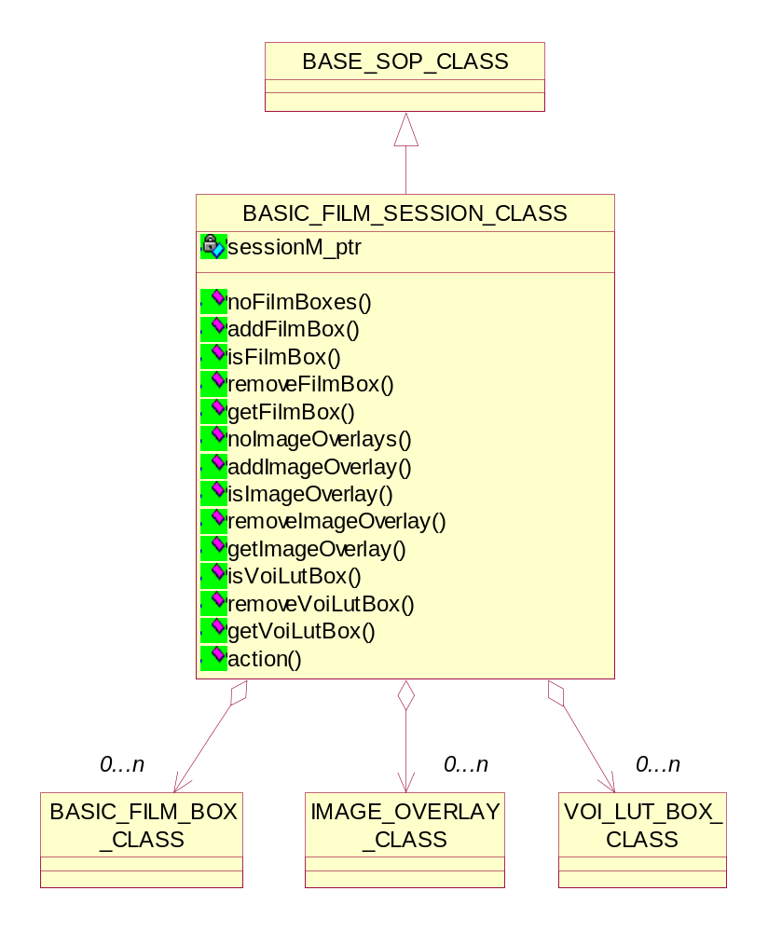
Figure 10 Class diagram of Basic Film Session

Adding/Removing the film boxes
void addFilmBox(BASIC_FILM_BOX_CLASS *filmBox_ptr);
bool removeFilmBox(UINT);

Adding/Removing the image overlay
void addImageOverlay(IMAGE_OVERLAY_CLASS *overlay_ptr);
bool removeImageOverlay(UINT);

Adding/Removing the VOI LUT boxes
void addVoiLutBox(VOI_LUT_BOX_CLASS *voiLut_ptr);
bool removeVoiLutBox(UINT);

Getting the number of film boxes
int noFilmBoxes();

Getting the number of image overlay
int noImageOverlays();

Getting the number of VOI LUT boxes
int noVoiLutBoxes();

Checking for the film boxes
int isImageBox(string);

Checking for the image overlay
int isAnnotationBox(string);

Checking for the VOI LUT boxes
int isAnnotationBox(string);

Getting the film box
BASIC_FILM_BOX_CLASS *getFilmBox(UINT);

Getting the image overlay
IMAGE_OVERLAY_CLASS *getImageOverlay(UINT);

Getting the VOI LUT box
VOI_LUT_BOX_CLASS *getVoiLutBox(UINT);

Printing the film
UINT16 action(BASIC_FILM_SESSION_CLASS*, int, bool, DCM_DATASET_CLASS**);

Basic Film Box Class
The Basic Film Box class is an abstraction of the presentation of one film of the film session. The Basic Film Box class describes the presentation parameters which are common for all images on a given sheet of film.

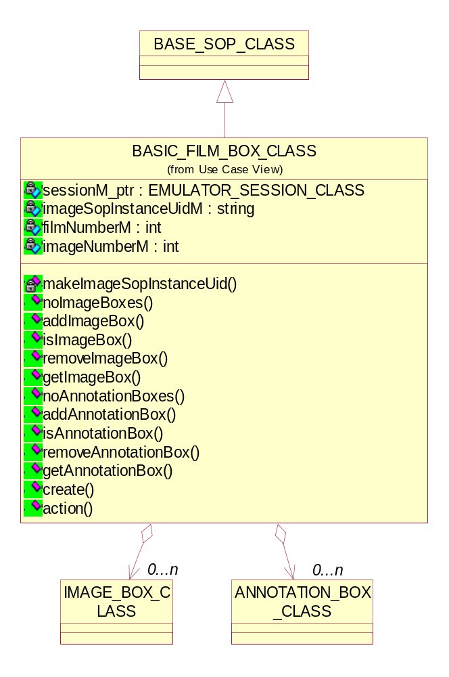
Figure 11 Class diagram of Basic Film Box

Adding/Removing the image boxes
void addImageBox(IMAGE_BOX_CLASS *imageBox_ptr);
bool removeImageBox(UINT);

Adding/Removing the annotation boxes
void addAnnotationBox(ANNOTATION_BOX_CLASS *annotationBox_ptr);
bool removeAnnotationBox(UINT);

Getting the number of image boxes
int noImageBoxes();

Getting the number of annotation boxes
int noAnnotationBoxes();

Checking for the image boxes
int isImageBox(string);

Checking for the annotation boxes
int isAnnotationBox(string);

Getting the image box
IMAGE_BOX_CLASS *getImageBox(UINT);

Getting the annotation box
ANNOTATION_BOX_CLASS *getAnnotationBox(UINT);

Creating the film box
UINT16 create(char*, DCM_DATASET_CLASS**);

Printing the film box
UINT16 action(BASIC_FILM_SESSION_CLASS*, int, bool, DCM_DATASET_CLASS**);

Print Queue Class
The Print Queue Class manages the various Print Jobs. The user can manipulate the
queue content : e.g. delete Print Jobs, prioritize Print Jobs.
The Print Job is an abstraction of the Print Job transaction and is the basic information entity to monitor the execution of the Print Process. A Print Job contains one film or multiple films, all belonging to the same film session.

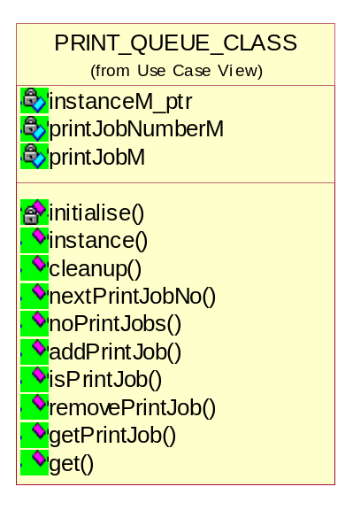
Figure 12 Class diagram of Print Queue

Getting the single instance of Print queue class
static PRINT_QUEUE_CLASS *instance();

Adding/Removing the printer jobs
void addPrintJob(PRINT_JOB_CLASS *printJob_ptr);
bool removePrintJob(UINT);

Getting the number of printer jobs
int noPrintJobs();

Getting the printer job
PRINT_JOB_CLASS *getPrintJob(UINT);

Checking for the printer job
int isPrintJob(string);

Getting the next printer job
int nextPrintJobNo();

Getting the print queue
UINT16 get(DCM_COMMAND_CLASS*, DCM_DATASET_CLASS**);

Printer Class
The Printer class prints a set of films, based on the information in the Print Job. The Printer class is an abstraction of the hard copy printer and is the basic Information Entity to monitor the status of the printer. The Printer SOP Instance is created by the SCP during start-up of the hard copy printer and has a well-known SOP Instance UID. This class is the singleton.

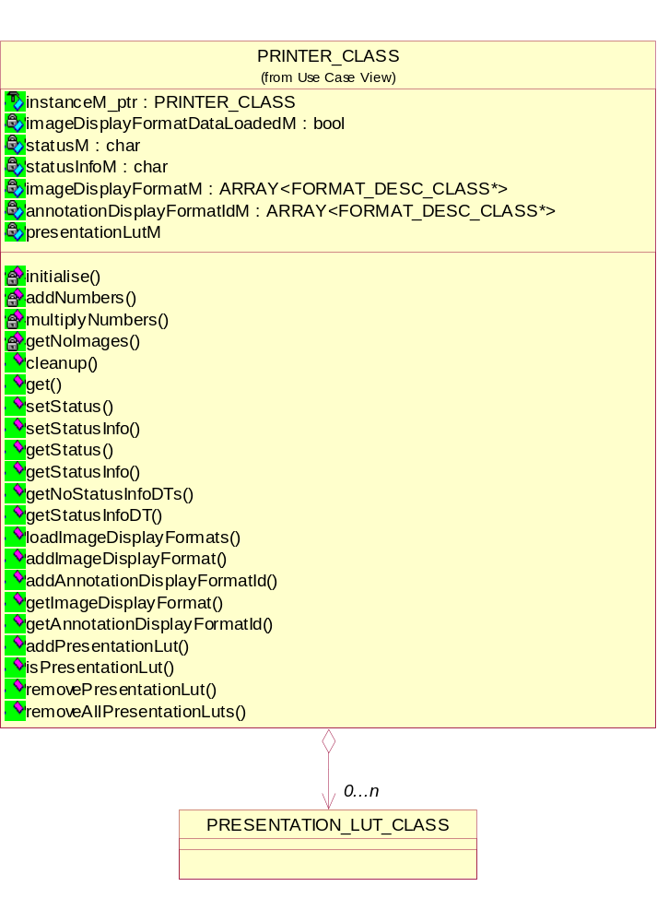
Figure 13 Class diagram of Printer

Getting the single instance of Printer class
static PRINTER_CLASS *instance();

Adding/Removing the printer jobs
void setStatus(char*);
char *getStatus();

Getting the number of printer jobs
void setStatusInfo(char *);
char *getStatusInfo();

Getting the printer ststus info defined term from definition file
UINT getNoStatusInfoDTs();
string getStatusInfoDT(UINT);

Getting the printer information
char *getName();
char *getManufacturer();
char *getModelName();
char *getSerialNumber();
char *getSoftwareVersion();
char *getCalibrationDate();
char *getCalibrationTime();

Managing the image display & annotation formats
bool loadImageDisplayFormats(string filename);
void addImageDisplayFormat(char*, int);
void addAnnotationDisplayFormatId(char*, int);
int getImageDisplayFormat(char*);
int getAnnotationDisplayFormatId(char*);

Managing the presentation LUTs
void addPresentationLut(PRESENTATION_LUT_CLASS *presentationLut_ptr);
int isPresentationLut(string);
bool removePresentationLut(UINT);
void removeAllPresentationLuts();

Managing the image boxes
int addNumbers(char*);
int multiplyNumbers(char*);
int getNoImages(char*);

Image Box Class
The Basic Image Box class is an abstraction of the presentation of an image and image related data in the image area of a film. The Basic Image Box class describes the presentation parameters and image pixel data, which apply to a single image of a sheet of film.
The Basic Image Box SOP Instance is created by the SCP at the time the Basic Film
Box SOP Instance is created, based on the value of the Basic Film Box Attribute Image Display Format (2010,0010).

Setting the dataset
UINT16 set(DCM_DATASET_CLASS*);

Annotation box class
The Basic Annotation Box class is an abstraction of the presentation of an annotation (e.g. text string) on a film. The Basic Annotation Box class describes the most used text related presentation parameters.
The Basic Annotation Box SOP Instance is created by the SCP at the time the Basic Film Box SOP Instance is created, based on the value of the Attribute Annotation Display Format ID (2010,0030) of the Basic Film Box.

Presentation LUT class
The Presentation LUT transforms the polarity pixel values into Presentation Values (P-Values), which are meaningful for display of the images.

Format Description Class
This class handles the image display formats mentioned in “ImageDisplayFormat.dat”.

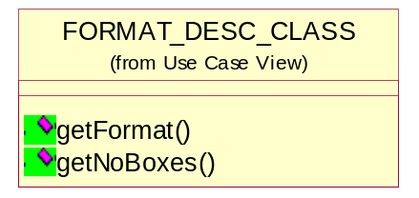
Figure 14 Class diagram of Format Description

Getting the number of image boxes
int getNoBoxes();

Getting the image display format
char *getFormat();

Media Concepts
Media support is responsible for data interchange through removable storage media.
DVT supports media validation. Media storage files and raw dataset files can be validated. DVT supports an in-depth validation of the DICOMDIR media file – full checks are made on both the syntax and semantics of the DICOMDIR media file content. References in the DICOMDIR can be followed so that other related media files are validated too.

Media Session: Media sessions are used when media files (DICOMDIR, DCM, Part-10 files) are being validated. When validating a DICOMDIR file any referenced files found in the DICOMDIR will also be validated.
The DVT configuration parameters used during a media session are stored in a media Session File.

File Set & Fie Ids: The DICOM File Service offers the ability to create and access one or more files in a File-set. A File-set is a collection of files that share a common naming space within which File IDs are unique.
A File ID is an ordered sequence of File ID Components. A File ID may contain one to eight components. Each Component is a string of one to eight characters from a subset of the G0 repertoire of ISO 8859.

DICOMDIR: A single File with a File ID, DICOMDIR, shall exist as a member of every File-set. This File ID is made of a single Component. It contains the DICOM Media Storage Directory, which includes general information about the whole File-set. If the DICOMDIR File does not exist in a File-set, the File-set does not conform to PS 3.10 of the DICOM Standard. The DICOMDIR shall not reference Files outside of the File-set to which it belongs. The DICOMDIR File shall use the Explicit VR Little Endian Transfer Syntax to encode the Media Storage Directory SOP Class.

Detail Design of Media Classes

Media File Header Class
The Media File Header consists of a 128 byte File Preamble, followed by a 4 byte DICOM prefix, followed by the File Meta Elements. This header shall be present in every DICOM file. The File Meta Information (FMI) includes identifying information on the encapsulated Data Set.
The File Preamble is available for use as defined by Application Profiles or specific implementations. It is intended to facilitate access to the images and other data in the DICOM file by providing compatibility with a number of commonly used computer image file formats. Whether or not the File Preamble contains information, the DICOM File content shall conform to the requirements of this Part and the Data Set shall conform to the SOP Class specified in the File Meta Information.
The four byte DICOM prefix shall contain the character string "DICM" encoded as uppercase characters of the ISO 8859 G0 Character Repertoire. This four-byte prefix is not structured as a DICOM Data Element with a Tag and a Length.

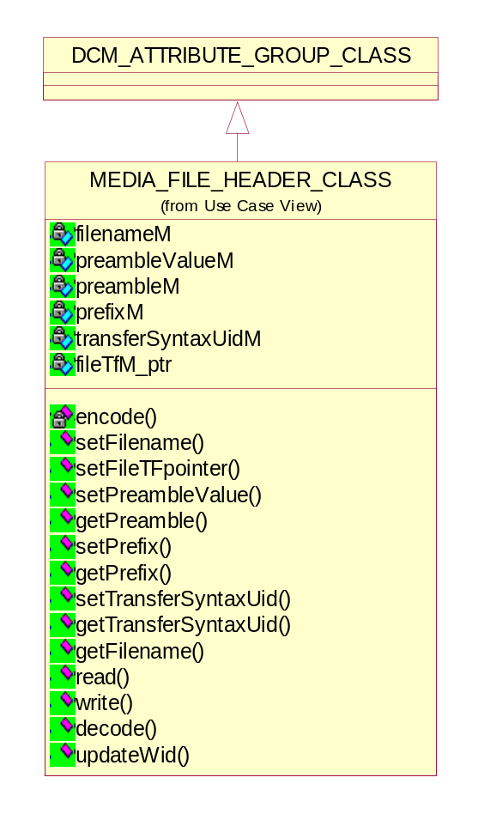
Figure 15 Class diagram of Media File Header
The Media File header class manages the FMI. The methods encode() & decode() are used for data interchange through removable storage media. Except for the 128 byte preamble and the 4 byte prefix, the File Meta Information shall be encoded using the Explicit VR Little Endian Transfer Syntax.

Setting/Getting the media filename
void setFilename(string);
const char* getFilename();

Setting the file handle
void setFileTFpointer(FILE_TF_CLASS*);

Setting/Getting the FMI Preamble
void setPreambleValue(BYTE);
const BYTE* getPreamble();

Setting/Getting the FMI Dicom prefix
void setPrefix(char*);
const BYTE* getPrefix();

Setting/Getting the FMI transfer syntax
void setTransferSyntaxUid(string);
const char* getTransferSyntaxUid();

Streaming the media file header and dataset from the media file
bool read(FILE_TF_CLASS*);
DCM_ATTRIBUTE_GROUP_CLASS *read();

Return value | Explanation
true | The operation is successful.
false | The operation is failed.

Streaming the media file preamble, DICOM prefix and file Meta information into the media file
bool write();
bool write(FILE_TF_CLASS*);

Return value | Explanation
true | The operation is successful.
false | The operation is failed.

Encoding media header to data transfer stream
bool encode(DATA_TF_CLASS&, UINT16 lastGroup = GROUP_EIGHT);

Return value | Explanation
true | The operation is successful.
false | The operation is failed.

Decoding media header from data transfer stream
bool decode(DATA_TF_CLASS&, UINT16 lastGroup = GROUP_EIGHT);

Return value | Explanation
true | The operation is successful.
false | The operation is failed.

Updating the warehouse with media header object
bool updateWid(BASE_WAREHOUSE_ITEM_DATA_CLASS*);

Return value | Explanation
true | The operation is successful.
false | The operation is failed.

Media File Dataset Class
Each File shall contain a single Data Set representing a single SOP Instance related to a single SOP Class (and corresponding IOD).
The Transfer Syntax used to encode the Data Set shall be the one identified by the Transfer Syntax UID of the DICOM File Meta Information.

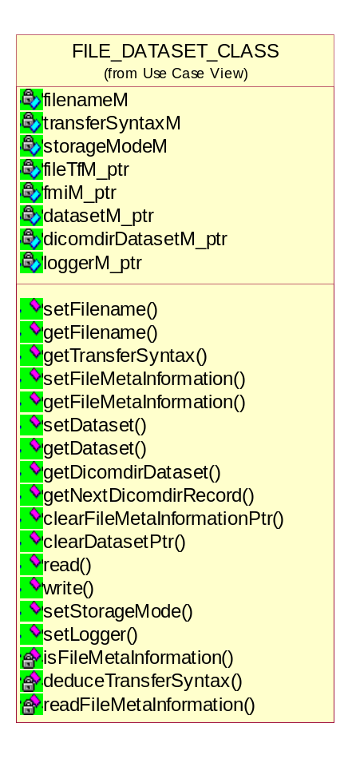
Figure 16 Class diagram of Media File Header

Setting/Getting the filename
void setFilename(string);
const char* getFilename();

Setting/Getting the FMI Transfer Syntax
void setTransferSyntaxUid(string);
const char* getTransferSyntaxUid();

Setting/Getting the FMI
void setFileMetaInformation(MEDIA_FILE_HEADER_CLASS*);
MEDIA_FILE_HEADER_CLASS* getFileMetaInformation();

Setting/Getting the Dataset
void setDataset(DCM_DATASET_CLASS*);
DCM_DATASET_CLASS* getDataset();

Getting the DICOMDIR dataset
DCM_DIR_DATASET_CLASS* getDicomdirDataset();

Get the next DICOMDIR Record
DCM_ITEM_CLASS* getNextDicomdirRecord();

Streaming the DICOM objects from the media file
bool read();
bool read(DCM_DATASET_CLASS*);

Return value | Explanation
true | The operation is successful.
false | The operation is failed.
Check if file starts with the Meta information. If so read it and leave the file offset at the beginning of the actual dataset.

Streaming the DICOM object to file
bool write(DCM_DATASET_CLASS*, bool autoCreateDirectory = true);
bool write(bool autoCreateDirectory = true);

Return value | Explanation
true | The operation is successful.
false | The operation is failed.

Clearing the File Meta Information
void clearFileMetaInformationPtr();

Clearing the Dataset
void clearDatasetPtr();

Setting the Storage Mode
void setStorageMode(STORAGE_MODE_ENUM);

Setting the Logger
void setLogger(LOG_CLASS*);

Media File Tail Class
In the media file, the last Data Element of a Data Set may be Data Element (FFFC,FFFC) if padding of a Data Set is desired when a file is written. The Value of this Data Set Trailing Padding Data Element (FFFC,FFFC) has no significance and shall be ignored by all DICOM implementations reading this Data Set.
This class provides the trailing padding according to sector size of removable media.

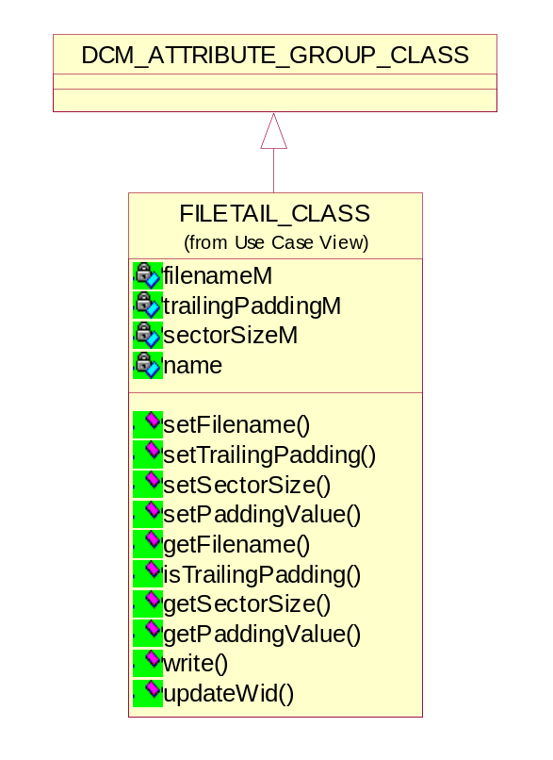
Figure 17 Class diagram of File tail

Setting/Getting the filename
void setFilename(string filename);
const char* getFilename();

Setting/Getting the Trailing Padding value
void setTrailingPadding(bool flag);
bool isTrailingPadding();

Setting/Getting the Sector Size
void setSectorSize(UINT sectorSize);
UINT getSectorSize();

Setting/Getting the Padding Value
void setPaddingValue(BYTE paddingValue);
BYTE getPaddingValue();

Updating the file tail object in warehouse
bool updateWid(BASE_WAREHOUSE_ITEM_DATA_CLASS*);

Return value | Explanation
true | The operation is successful.
false | The operation is failed.

Streaming the dataset trailing padding into the media file
bool write(bool autoCreateDirectory);
Return value | Explanation
true | The operation is successful.
false | The operation is failed.

Scripting Concept
The scripting language is a merge of the VTS and ADVT scripting languages. A detailed description of the language is given in [SCRIPT].

The scripting component is in fact thin layer above the other sub-components. The objects created in a script must be stored somewhere. For this purpose an object warehouse is created. This construction also allows reuse of objects between different sessions (scripts)

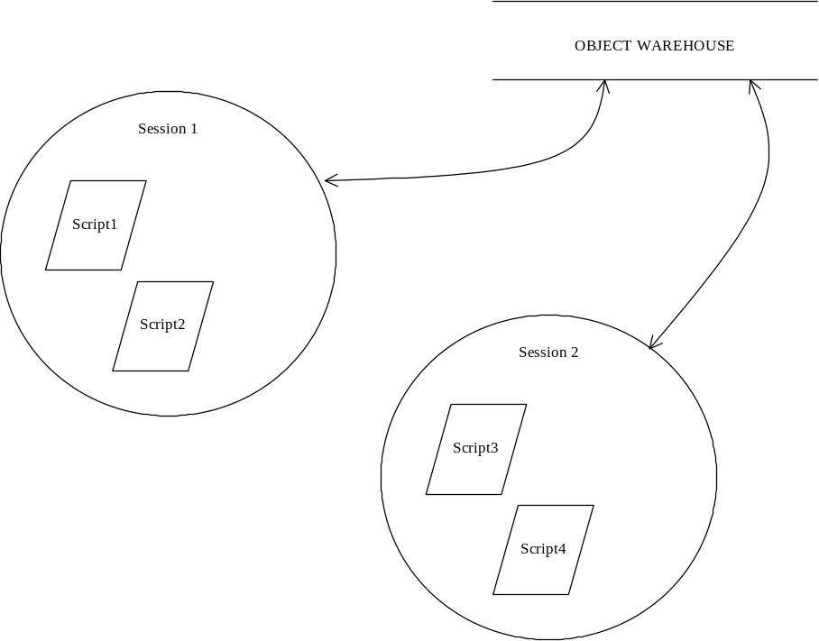
Figure 18 Object Warehouse, scripts and sessions

Within a session scripts are parsed. During parsing objects are created, updated and deleted. When a session has finished the warehouse will not be emptied automatically. It is possible to keep objects in the warehouse for use in other sessions and/or scripts. The user has control over the objects in the warehouse via the scripts and the GUI.

Script Language
The script language of the tool provides the mechanism to simulate DICOM behavior. A large diversity of commands is available [SCRIPT].

DICOMScript
A DICOMScript (.DS) describes a single Test Scenario. ACSE Requests & Responses and DIMSE Command / IOD combinations are used to perform a given Test Scenario.
DVT interprets a DICOMScript in order to perform a Test Scenario. See sections on Programming DVT and Advanced Programming for details of DICOMScript contents.
DICOMScripts should be written according to the role played by DVT:
- SCU - write a DICOMScript that plays the SCU role in a given Test Scenario.
- SCP - write a DICOMScript that plays the SCP role in a given Test Scenario.
- FSC – write a DICOMScript that plays the FSC role in a given Test Scenario (creates File-sets).

DICOMSuperScript
A DICOMSuperScript (.DSS) contains a list of DICOMScript (filenames) that together are used to describe a Test Scenario. DVT executes the DICOMScripts in the order given in the DICOMSuperScript.

VBScript
A DICOM test scenario can be written using the DVTK assemblies in VBScript. The User should have knowledge of VBScript programming to be able to write DVT VBScripts.
DICOMScript have following shortcomings:
  - It is in-house built and contains limited number of statements.
  - It does not contain conditional statements (if, else etc) so user is unable to simulate complex test scenarios.
  - A separate layer is implemented for understanding DICOMScript constructs.
  - A parser (Lex-yacc) is needed to parse the script files.

The direct advantage of the VB script is that user can directly call DICOM commands from test script and also supported by .net platform. Also it is a full-fledged script language and provides all the constructs to user.

Detail Design of Script classes

Parser Instance Class

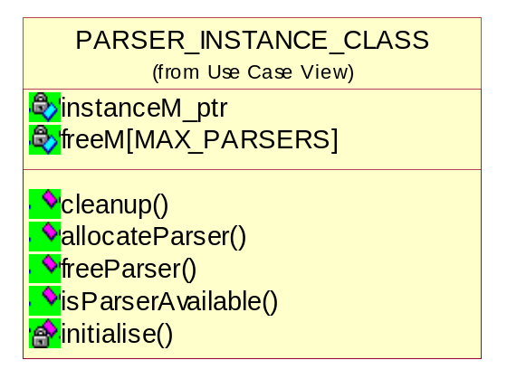
Figure 19 Class diagram of Parser Instance

Cleaning up instance
void cleanup();

Allocating the first free parser
int allocateParser();

Freeing up the indexed parser
void freeParser(int);

Checking if a parser is available
bool isParserAvailable();
Return value | Explanation
true | The operation is successful.
false | The operation is failed.

Initializing the parser instances
void initialise();

DICOM Script Class
This class represents the DICOM script file. It derived from BASE_FILE_CLASS. The script files are ASCII text files and can be modified by user. The Lex/yacc parser should be written for parsing the script files.

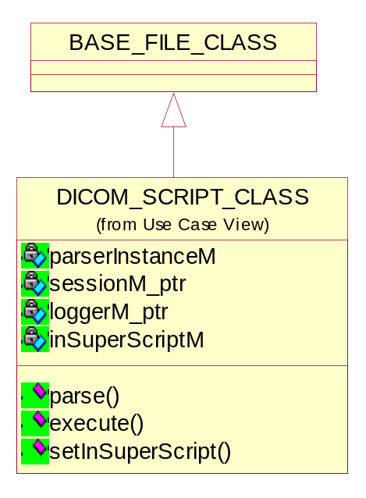
Figure 20 Class diagram of DICOM Script

Parsing the script file
bool parse();
Return value | Explanation
true | The operation is successful.
false | The operation is failed.

Executing the script file
bool execute();
Return value | Explanation
true | The operation is successful.
false | The operation is failed.

Setting the SuperScript file
void setInSuperScript(bool flag);

DICOM Super Script Class
This class represents the DICOM super script file. It derived from BASE_FILE_CLASS. The super script files are ASCII text files and can be modified by user. The Lex/yacc parser should be written for parsing the super script files.

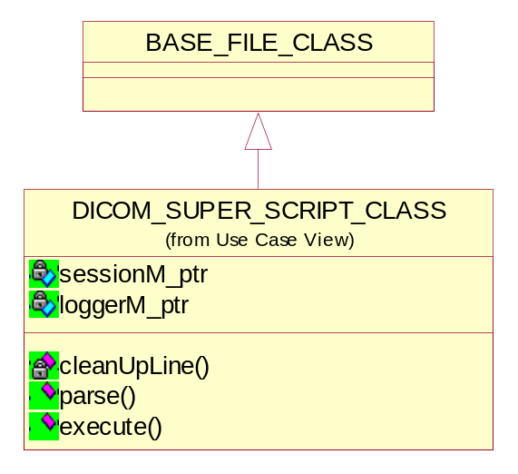
Figure 21 Class diagram of DICOM super script

Executing super script file
bool execute();
Return value | Explanation
true | The operation is successful.
false | The operation is failed.

Parsing the super script file
bool parse();
Return value | Explanation
true | The operation is successful.
false | The operation is failed.

Removing unwanted characters from super script file
int cleanUpLine(char*);

